WOMEN FORTUNE TECH INTERNSHIP
MARYAM REHAN
CYBER SECURITY ANALYST
WEEK 02
Task: Wireshark Network Traffic Analysis
Objective
Capture and analyze network traffic generated by your own system and identify different protocols, IP addresses, ports, and TCP communication.
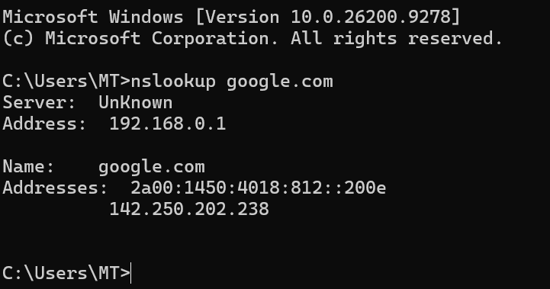
Figure : Wireshark Packet Capture
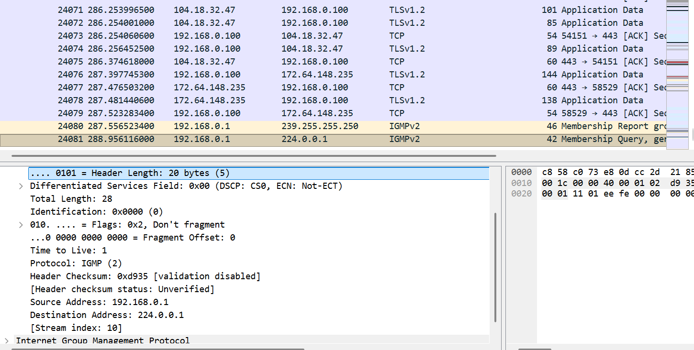
Network traffic was captured using Wireshark while performing normal network activities.
The captured packets were analyzed using Wireshark display filters.

Figure : DNS queries and responses captured using the dns display filter
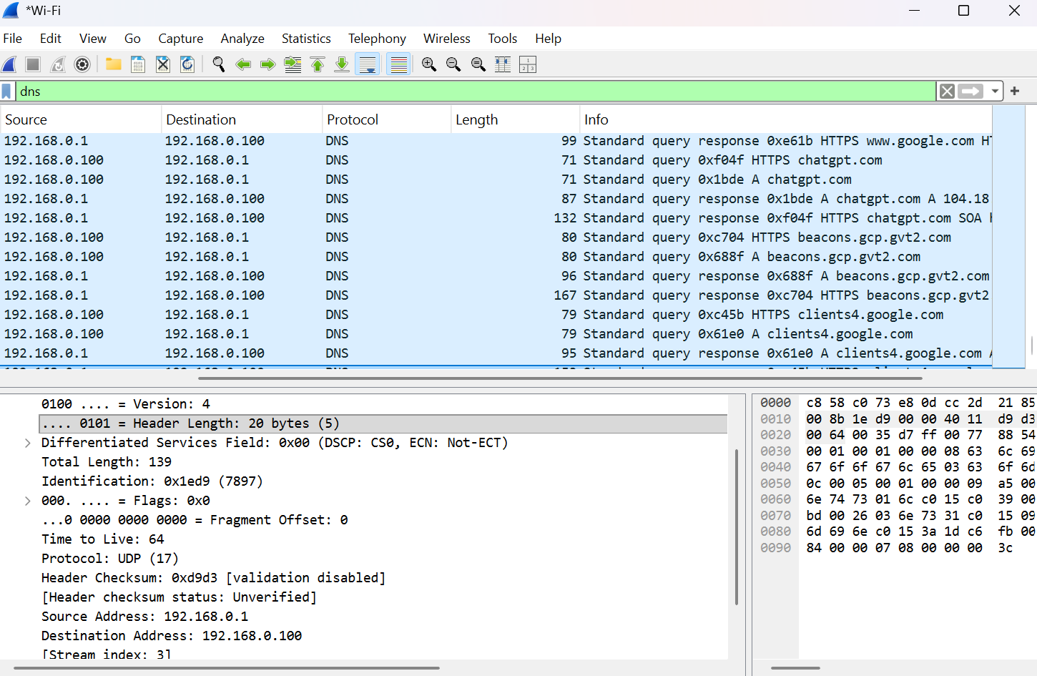
DNS queries and responses were identified using the dns display filter. The local system 192.168.0.100 communicated with the DNS server 192.168.0.1. DNS communication was observed over UDP.
Figure : UDP Traffic Analysis Using the udp Display Filter
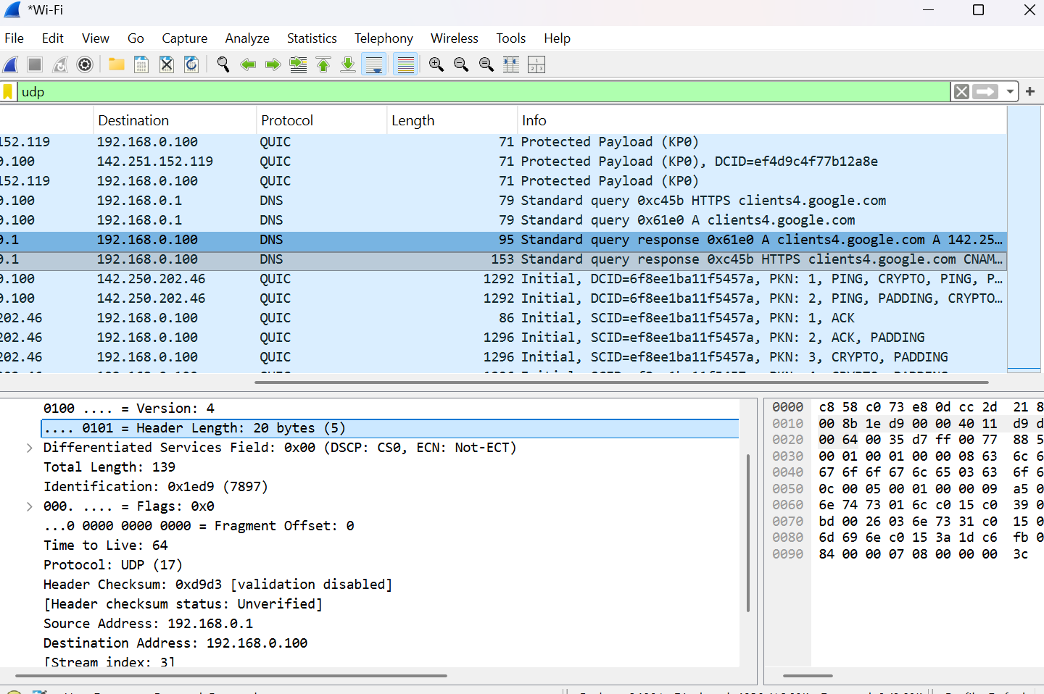
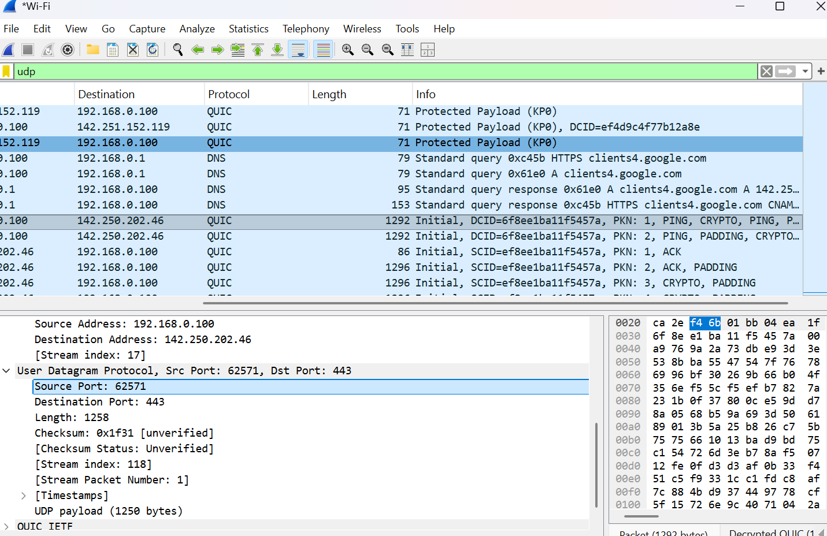
UDP traffic was identified using the udp display filter.
Figure: TCP Connection Termination using FIN, ACK packets
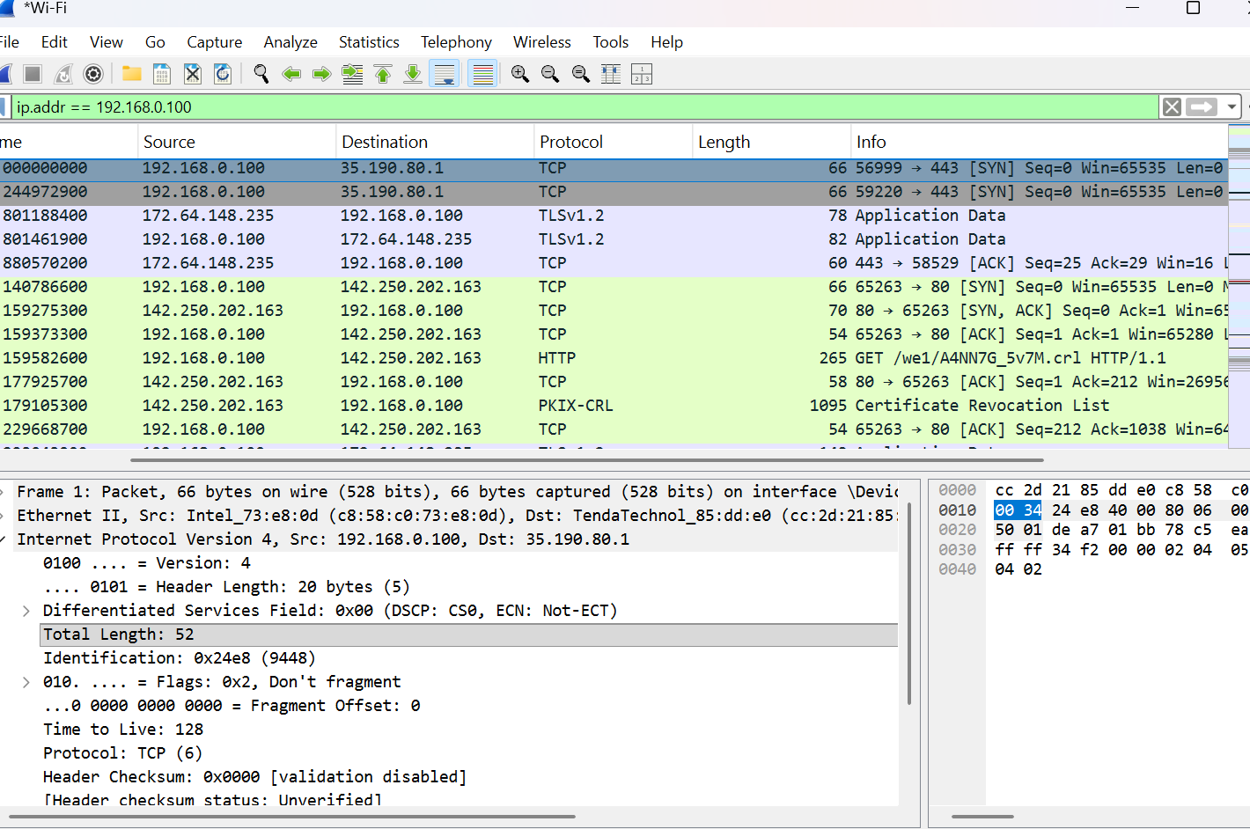
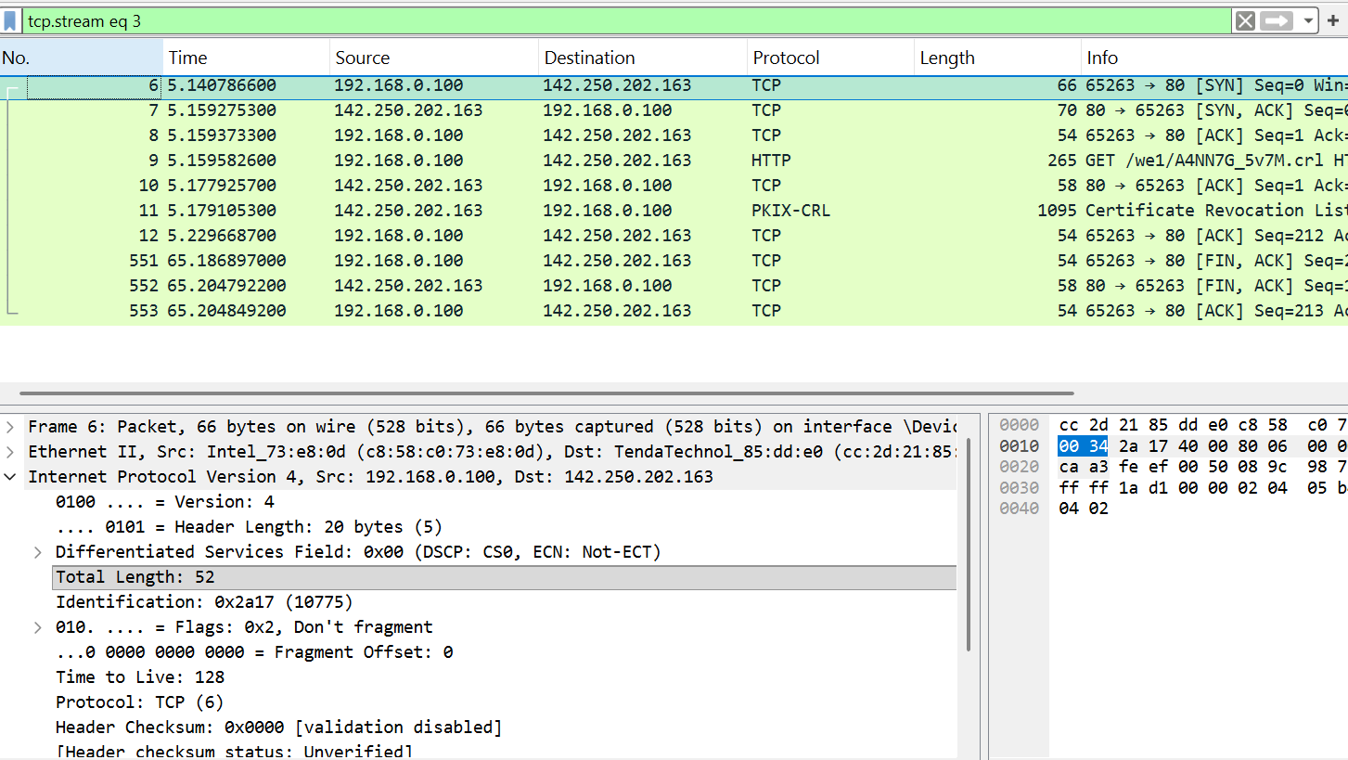
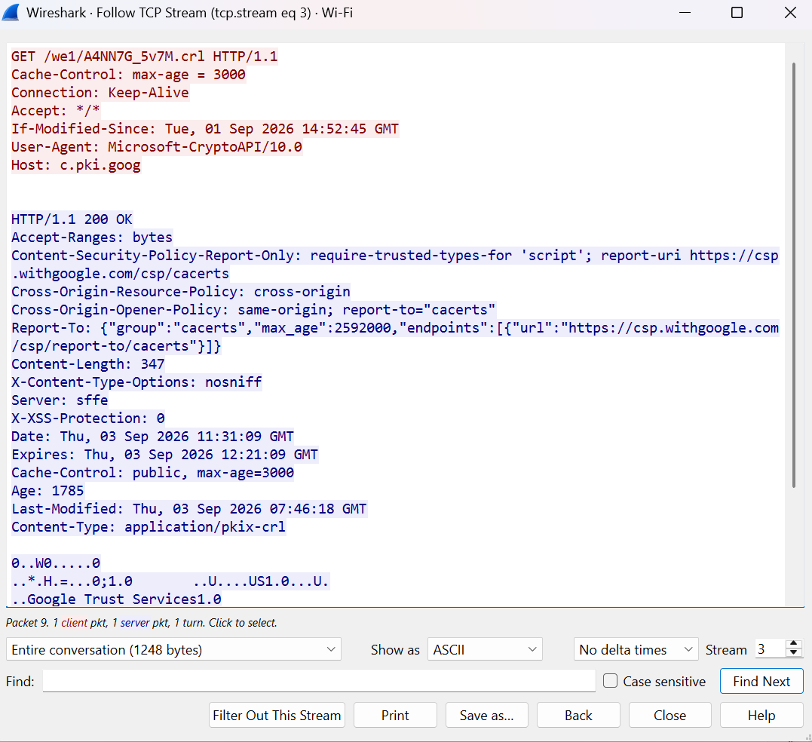
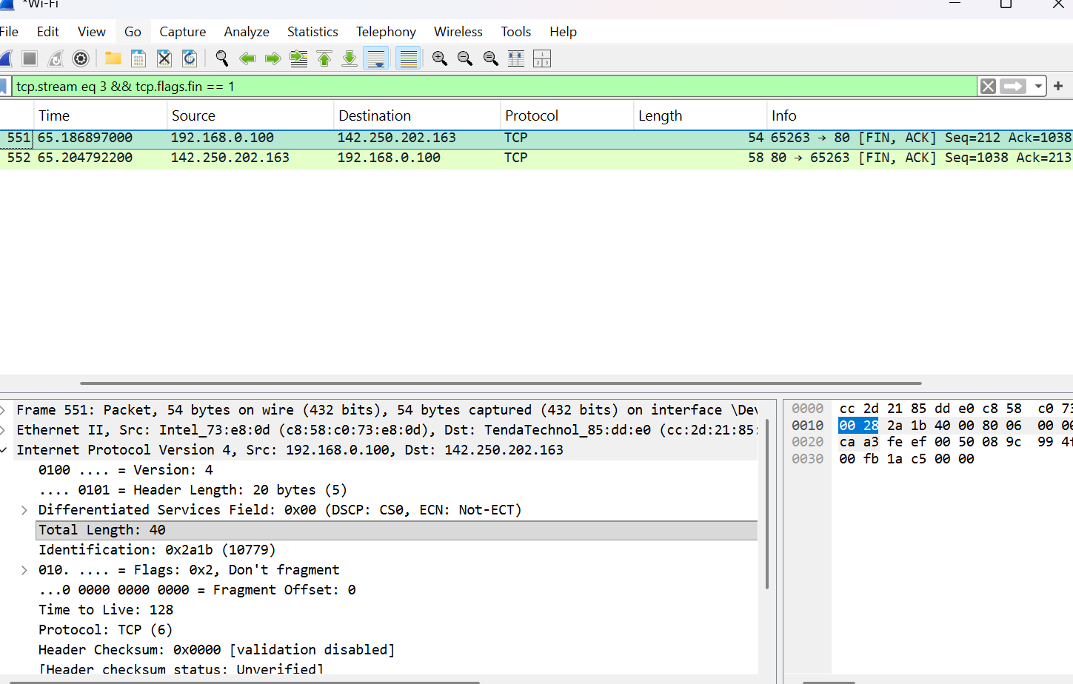
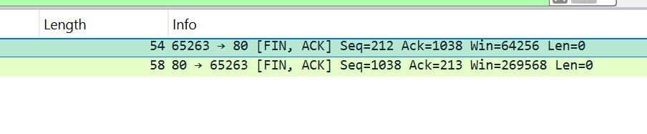
Packet 551 shows the client sending FIN, ACK, while Packet 552 shows the server responding with FIN, ACK. This confirms successful TCP connection termination.
Figure: Identification of System IP and Destination IP Addresses
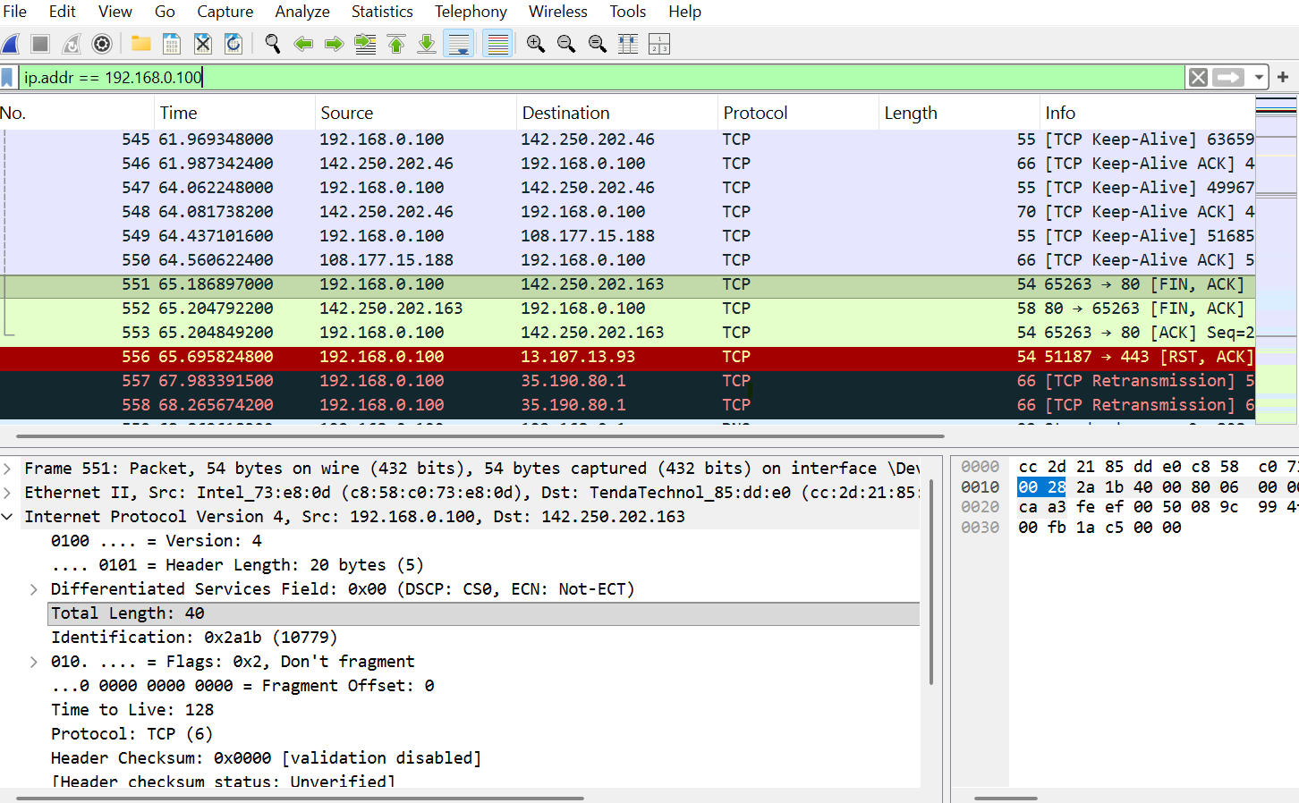
The system IP address identified from the captured traffic is 192.168.0.100. Several destination IP addresses were observed, including 142.250.202.46 and 108.177.15.188.

Figure: DNS Queries and Responses captured in Wireshark
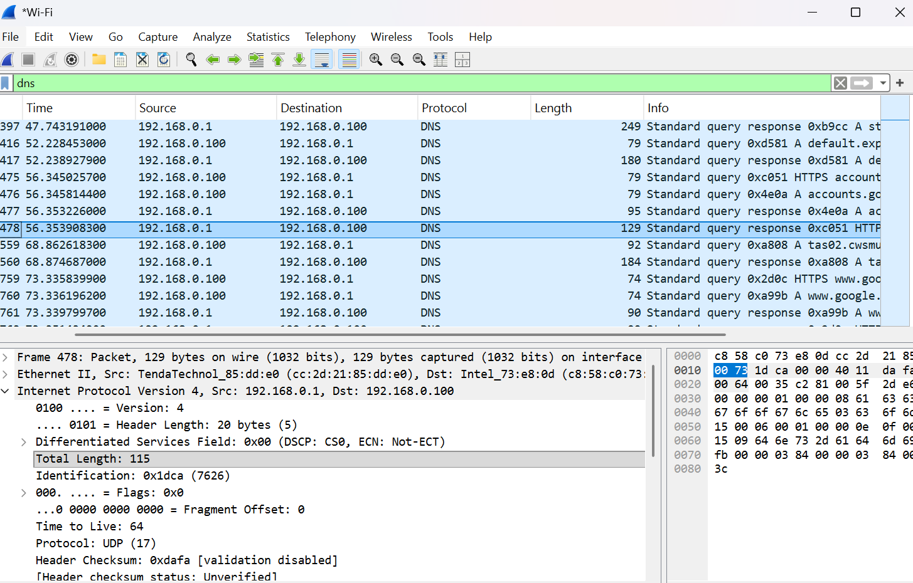
The captured traffic shows DNS queries sent from the local system 192.168.0.100 to the DNS server 192.168.0.1. The DNS server responds back to the system with the requested information. DNS communication is carried over UDP.

Figure: TCP Traffic Captured in Wireshark
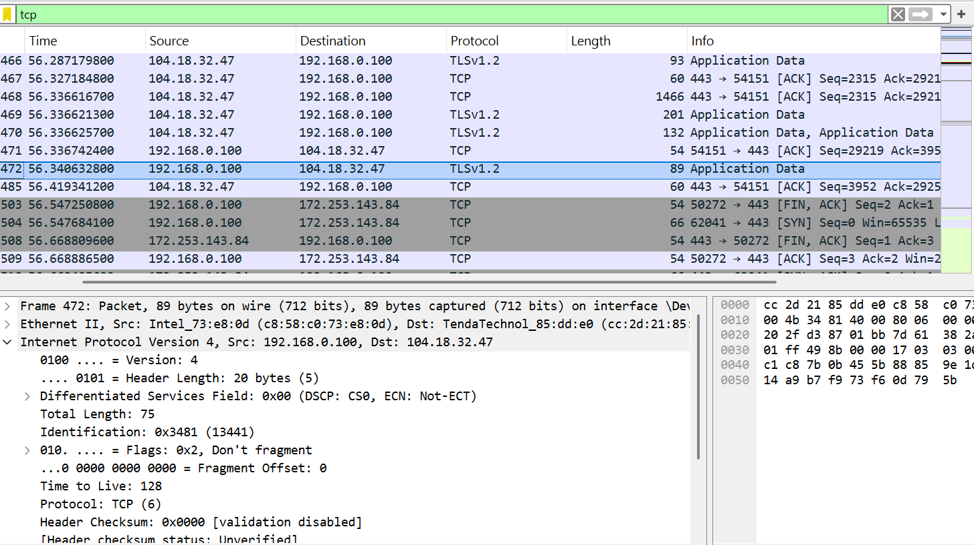
The captured traffic contains TCP communication between the local system (192.168.0.100) and remote servers. TCP traffic is observed on port 443, which is commonly used for secure web communication.

Protocols Identified
The captured network traffic contains different protocols including TCP, UDP, DNS, and TLS
these protocols were identified using Wireshark display filters.
TCP Source IP + Port / Destination IP + Port

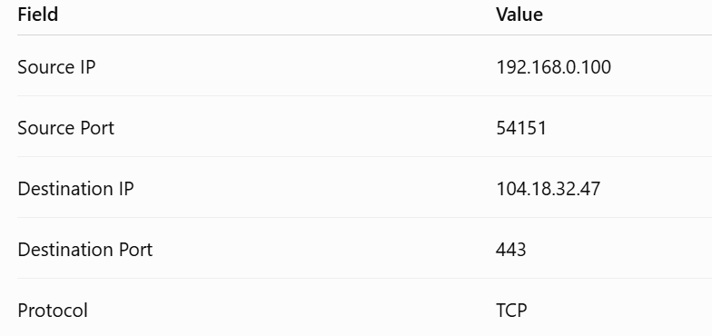

Figure: TCP Flags & Establishment
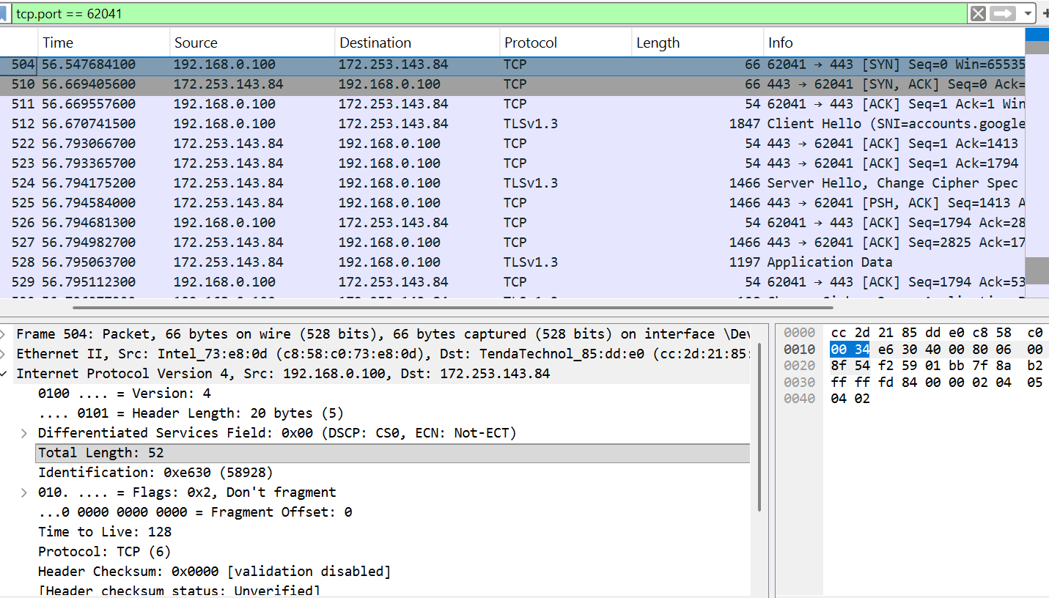
The TCP connection was established using the standard three-way handshake. Frame 504 shows the client sending a SYN packet, Frame 510 shows the server responding with SYN-ACK, and Frame 511 shows the client sending ACK. This confirms successful TCP connection establishment.
Figure: Wireshark Display Filters
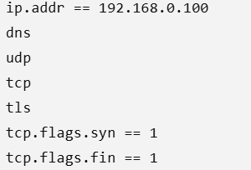
These Wireshark display filters were used to locate and analyze IP, DNS, UDP, TCP, TLS, connection establishment, and connection termination traffic.
Conclusion
The network traffic generated by the system was successfully captured and analyzed using Wireshark. The analysis identified the system IP address, destination IP addresses, DNS queries and responses, TCP and UDP traffic, different protocols, and a complete TCP connection including its establishment and termination.

